THEORY OF COMPUTATION

Question 1. Design a Finite Automata (FA) that accepts all strings over S = {0, 1} having three consecutive 1's as a substring. Write a program to simulate this FA.

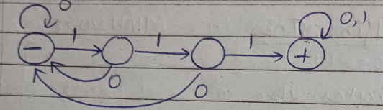

#include <iostream>
#include <string>
using namespace std;

void State1(string w, int i);
void State2(string w, int i);
void State3(string w, int i);
void State4(string w, int i);
int main() {
string str;
cout << "Enter the string: ";
cin >> str;
State1(str, 0);
return 0;
}
void State1(string w, int i) {
cout << "State 1" << endl;
if (i == w.length()) {
cout << "String is rejected" << endl;
return;}
else {
if (w[i] == '1')
State2(w, i + 1);
if (w[i] == '0')
State1(w, i + 1);
}}
void State2(string w, int i) {
cout << "State 2" << endl;
if (i == w.length()) {
cout << "String is rejected" << endl;
return;}
else {
if (w[i] == '1')
State3(w, i + 1);
if (w[i] == '0')
State1(w, i + 1);
}}
void State3(string w, int i) {
cout << "State 3" << endl;
if (i == w.length()) {
cout << "String is rejected" << endl;
return;}
else {
if (w[i] == '1')
State4(w, i + 1);
if (w[i] == '0')
State1(w, i + 1);
}}
void State4(string w, int i) {
cout << "State 4" << endl;
if (i == w.length()) {
cout << "String is accepted" << endl;
return;}
else
if (w[i] == '1' || w[i] == '0')
State4(w, i + 1);
}

Question 2. Design a Finite Automata (FA) that accepts all strings over S={0, 1} having either exactly two 1's or exactly three 1's, not more nor less Write a program to simulate this FA.

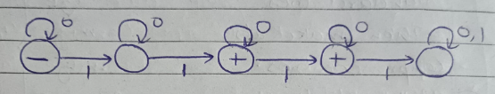

#include <iostream>
#include <string>
using namespace std;

void State1(string w, int i);
void State2(string w, int i);
void State3(string w, int i);
void State4(string w, int i);
void State5(string w, int i);

int main() {
string str;
cout << "Enter the string: ";
cin >> str;
State1(str, 0);
return 0;
}
void State1(string w, int i) {
cout << "State 1" << endl;
if (i == w.length()) {
cout << "String is accepted" << endl;
return;}
else {
if (w[i] == '1')
State2(w, i + 1);
if (w[i] == '0')
State1(w, i + 1);
}}
void State2(string w, int i) {
cout << "State 2" << endl;
if (i == w.length()) {
cout << "String is rejected" << endl;
return;}
else {
if (w[i] == '1')
State3(w, i + 1);
if (w[i] == '0')
State2(w, i + 1);
}}
void State3(string w, int i) {
cout << "State 3" << endl;
if (i == w.length()) {
cout << "String is accepted" << endl;
return;}
else {
if (w[i] == '1')
State4(w, i + 1);
if (w[i] == '0')
State3(w, i + 1);
}}
void State4(string w, int i) {
cout << "State 4" << endl;
if (i == w.length()) {
cout << "String is accepted" << endl;
return;}
else {
if (w[i] == '1')
State5(w, i + 1);
if (w[i] == '0')
State4(w, i + 1);
}}
void State5(string w, int i) {
cout << "State 5" << endl;
if (i == w.length()) {
cout << "String is rejected" << endl;
return;}
else
if (w[i] == '1' || w[i] == '0')
State5(w, i + 1);
}

3. Design a Finite Automata (FA) that accepts language L1, over S={a, b}, comprising of all strings (of length 4 or more) having first two characters same as the last two. Write a program to simulate this FA.

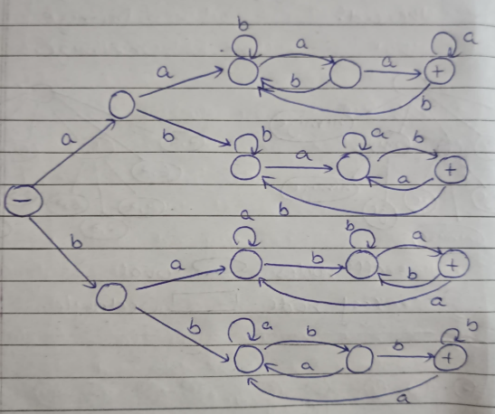

#include <iostream>
#include <string>
using namespace std;

void State0(string w, int i);
void State1(string w, int i);
void State2(string w, int i);
void State3(string w, int i);
void State4(string w, int i);
void State5(string w, int i);
void State6(string w, int i);
void State7(string w, int i);
void State8(string w, int i);
void State9(string w, int i);
void State10(string w, int i);
void State11(string w, int i);
void State12(string w, int i);
void State13(string w, int i);
void State14(string w, int i);

int main() {
string str;
cout << "Enter the string: ";
cin >> str;
State0(str, 0);
return 0;
}
void State0(string w, int i) {
cout << "State 0" << endl;
if (i == w.length()) {
cout << "String is rejected" << endl;
return;}
else {
if (w[i] == 'a')
State1(w, i + 1);
if (w[i] == 'b')
State8(w, i + 1);
}}
void State1(string w, int i) {
cout << "State 1" << endl;
if (i == w.length()) {
cout << "String is rejected" << endl;
return;}
else {
if (w[i] == 'a')
State2(w, i + 1);
if (w[i] == 'b')
State5(w, i + 1);
}}
void State2(string w, int i) {
cout << "State 2" << endl;
if (i == w.length()) {
cout << "String is rejected" << endl;
return;}
else {
if (w[i] == 'a')
State3(w, i + 1);
if (w[i] == 'b')
State2(w, i + 1);
}}
void State3(string w, int i) {
cout << "State 3" << endl;
if (i == w.length()) {
cout << "String is rejected" << endl;
return;}
else {
if (w[i] == 'a')
State4(w, i + 1);
if (w[i] == 'b')
State2(w, i + 1);
}}
void State4(string w, int i) {
cout << "State 4" << endl;
if (i == w.length()) {
cout << "String is accepted" << endl;
return;}
else {
if (w[i] == 'a')
State4(w, i + 1);
if (w[i] == 'b')
State2(w, i + 1);
}}
void State5(string w, int i) {
cout << "State 5" << endl;
if (i == w.length()) {
cout << "String is rejected" << endl;
return;}
else {
if (w[i] == 'a')
State6(w, i + 1);
if (w[i] == 'b')
State5(w, i + 1);
}}
void State6(string w, int i) {
cout << "State 6" << endl;
if (i == w.length()) {
cout << "String is rejected" << endl;
return;}
else {
if (w[i] == 'a')
State6(w, i + 1);
if (w[i] == 'b')
State7(w, i + 1);
}}
void State7(string w, int i) {
cout << "State 7" << endl;
if (i == w.length()) {
cout << "String is accepted" << endl;
return;}
else {
if (w[i] == 'a')
State6(w, i + 1);
if (w[i] == 'b')
State5(w, i + 1);
}}
void State8(string w, int i) {
cout << "State 8" << endl;
if (i == w.length()) {
cout << "String is rejected" << endl;
return;}
else {
if (w[i] == 'a')
State9(w, i + 1);
if (w[i] == 'b')
State12(w, i + 1);
}}
void State9(string w, int i) {
cout << "State 9" << endl;
if (i == w.length()) {
cout << "String is rejected" << endl;
return;}
else {
if (w[i] == 'a')
State9(w, i + 1);
if (w[i] == 'b')
State10(w, i + 1);
}}
void State10(string w, int i) {
cout << "State 10" << endl;
if (i == w.length()) {
cout << "String is rejected" << endl;
return;}
else {
if (w[i] == 'a')
State11(w, i + 1);
if (w[i] == 'b')
State10(w, i + 1);
}}
void State11(string w, int i) {
cout << "State 11" << endl;
if (i == w.length()) {
cout << "String is accepted" << endl;
return;}
else {
if (w[i] == 'a')
State9(w, i + 1);
if (w[i] == 'b')
State10(w, i + 1);
}}
void State12(string w, int i) {
cout << "State 12" << endl;
if (i == w.length()) {
cout << "String is rejected" << endl;
return;}
else {
if (w[i] == 'a')
State12(w, i + 1);
if (w[i] == 'b')
State13(w, i + 1);
}}
void State13(string w, int i) {
cout << "State 13" << endl;
if (i == w.length()) {
cout << "String is rejected" << endl;
return;}
else {
if (w[i] == 'a')
State12(w, i + 1);
if (w[i] == 'b')
State14(w, i + 1);
}}
void State14(string w, int i) {
cout << "State 14" << endl;
if (i == w.length()) {
cout << "String is accepted" << endl;
return;}
else {
if (w[i] == 'a')
State12(w, i + 1);
if (w[i] == 'b')
State14(w, i + 1);
}}

4. Design a Finite Automata (FA) that accepts language L2, over S= {a, b} where L2= a(a+b)*b. Write a program to simulate this FA.

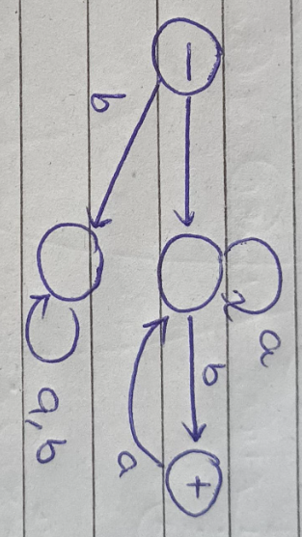

#include <iostream>
#include <string>
using namespace std;

void State0(string w, int i);
void State1(string w, int i);
void State2(string w, int i);
void State3(string w, int i);

int main() {
string str;
cout << "Enter the string: ";
cin >> str;
State0(str, 0);
return 0;
}
void State0(string w, int i) {
cout << "State 0" << endl;
if (i == w.length()) {
cout << "String is rejected" << endl;
return;}
else {
if (w[i] == 'a')
State1(w, i + 1);
if (w[i] == 'b')
State3(w, i + 1);
}}
void State1(string w, int i) {
cout << "State 1" << endl;
if (i == w.length()) {
cout << "String is rejected" << endl;
return;}
else {
if (w[i] == 'a')
State1(w, i + 1);
if (w[i] == 'b')
State2(w, i + 1);
}}
void State2(string w, int i) {
cout << "State 2" << endl;
if (i == w.length()) {
cout << "String is accepted" << endl;
return;}
else {
if (w[i] == 'a')
State1(w, i + 1);
if (w[i] == 'b')
State2(w, i + 1);
}}
void State3(string w, int i) {
cout << "State 3" << endl;
if (i == w.length()) {
cout << "String is rejected" << endl;
return;}
else {
if (w[i] == 'a')
State3(w, i + 1);
if (w[i] == 'b')
State3(w, i + 1);
}}

5. Design a Finite Automata (FA) that accepts language EVEN-EVEN over S={a, b}. Write a program to simulate this FA

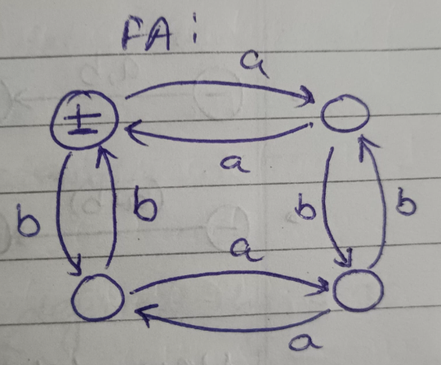

#include <iostream>
#include <string>
using namespace std;

void State1(string w, int i);
void State2(string w, int i);
void State3(string w, int i);
void State4(string w, int i);

int main() {
string str;
cout << "Enter the string: ";
cin >> str;
State1(str, 0);
return 0;
}
void State1(string w, int i) {
cout << "State 1" << endl;
if (i == w.length()) {
cout << "String is accepted" << endl;
return;}
else {
if (w[i] == 'a')
State2(w, i + 1);
if (w[i] == 'b')
State3(w, i + 1);
}}
void State2(string w, int i) {
cout << "State 2" << endl;
if (i == w.length()) {
cout << "String is rejected" << endl;
return;}
else {
if (w[i] == 'a')
State1(w, i + 1);
if (w[i] == 'b')
State4(w, i + 1);
}}
void State3(string w, int i) {
cout << "State 3" << endl;
if (i == w.length()) {
cout << "String is rejected" << endl;
return;}
else {
if (w[i] == 'a')
State4(w, i + 1);
if (w[i] == 'b')
State1(w, i + 1);
}}
void State4(string w, int i) {
cout << "State 4" << endl;
if (i == w.length()) {
cout << "String is rejected" << endl;
return;}
else {
if (w[i] == 'a')
State3(w, i + 1);
if (w[i] == 'b')
State2(w, i + 1);
}}

Question 7. Design a PDA and write a program for simulating the machine which accepts the language {anbn where n>0, S= {a, b}}.

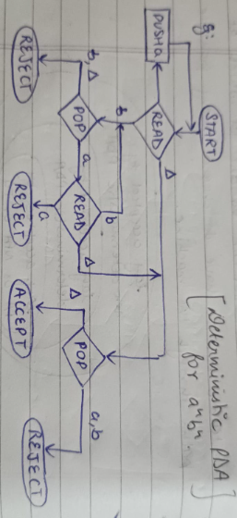

#include <iostream>
#include <string>
#include <stack>
using namespace std;

void Read1(const string& w, stack<char>& st, int i);
void Read2(const string& w, stack<char>& st, int i);

int main() {
string str;
cout << "Enter the string: ";
cin >> str;
stack<char> st;
Read1(str, st, 0);
return 0;}

void Read1(const string& w, stack<char>& st, int i) {
cout << "Read1 at " << i << endl;
if (i == w.length()) {
if (st.empty())
cout << "String is accepted\n";
else
cout << "String is rejected\n";
return;}
if (w[i] == 'a') {
st.push('a');
Read1(w, st, i + 1);
return;}
if (w[i] == 'b')
if (!st.empty() && st.top() == 'a') {
st.pop();
Read2(w, st, i + 1);
return;}
cout << "String is rejected\n";}

void Read2(const string& w, stack<char>& st, int i) {
cout << "Read2 at " << i << endl;
if (i == w.length()) {
if (st.empty())
cout << "String is accepted\n";
else
cout << "String is rejected\n";
return;}
if (w[i] == 'b')
if (!st.empty() && st.top() == 'a'){
st.pop();
Read2(w, st, i + 1);
return;}
cout << "String is rejected\n";}

Question 8. Design a PDA and write a program for simulating the machine which accepts the language {wXwr} w is any string over S={a, b} and wr is reverse of that string and X is a special symbol }.

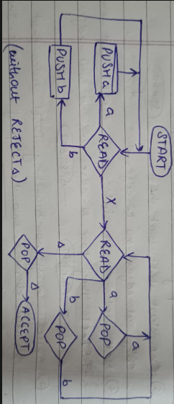

#include <iostream>
#include <string>
#include <stack>
using namespace std;

void Read1(const string& w, stack<char>& st, int i);
void Read2(const string& w, stack<char>& st, int i);

int main() {
string str;
cout << "Enter the string: ";
cin >> str;
stack<char> st;
Read1(str, st, 0);
return 0;}

void Read1(const string& w, stack<char>& st, int i) {
cout << "Read1 at " << i << endl;
if (w[i] == 'a') {
st.push('a');
Read1(w, st, i + 1);
return;}
if (w[i] == 'b') {
st.push('b');
Read1(w, st, i + 1);
return;}
if (w[i] == 'X')
return Read2(w, st, i + 1);
cout << "String is rejected\n";}

void Read2(const string& w, stack<char>& st, int i) {
cout << "Read2 at " << i << endl;
if (i == w.length() && st.empty()){
cout << "String is accepted\n";
return;}
if (w[i] == 'a')
if (!st.empty() && st.top() == 'a'){
st.pop();
Read2(w, st, i + 1);
return;}
if (w[i] == 'b')
if (!st.empty() && st.top() == 'b'){
st.pop();
Read2(w, st, i + 1);
return;}
cout << "String is rejected\n";}
Question 9. Design and simulate a Turing Machine that accepts the language a^nb^nc^n where n >0.

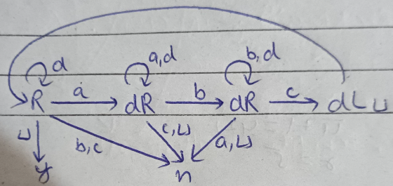

#include <iostream>
#include <string>
using namespace std;

void moveRightToNext(string &tape, int &head, char target);
bool process(string &tape);

int main() {
string tape;
cout << "Enter string: ";
cin >> tape;
if (process(tape))
cout << "String is accepted\n";
else
cout << "String is rejected\n";
return 0;
}

void moveRightToNext(string &tape, int &head, char target){
while (head < (int)tape.size() && tape[head] != target) head++;}

bool process(string &tape) {
int head = 0;
while (true) {
moveRightToNext(tape, head, 'a');
if (head == tape.size()) break;
tape[head] = 'd';
head++;
moveRightToNext(tape, head, 'b');
if (head == tape.size()) return false;
tape[head] = 'd';
head++;
moveRightToNext(tape, head, 'c');
if (head == tape.size()) return false;
tape[head] = 'd';
head = 0;
}
for (int i=0; i<tape.size(); i++)
if (tape[i] != 'd') return false;
return true;
}

Question 10. Design and simulate a Turing Machine which will increment the given binary number by 1.

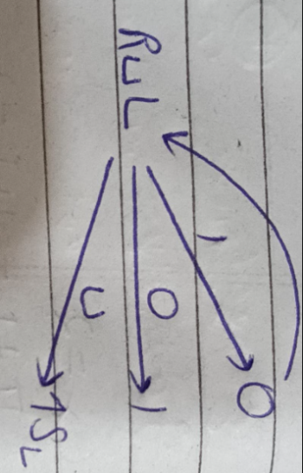

#include <iostream>
#include <string>
using namespace std;

bool incrementTM(string &tape) {
int head = tape.size() - 1;
while (head >= 0) {
if (tape[head] == '0') {
tape[head] = '1';
return true;}
tape[head] = '0';
head--;
}
tape.insert(tape.begin(), '1');
return true;
}

int main() {
string tape;
cout << "Enter binary string: ";
cin >> tape;
incrementTM(tape);
cout << "Incremented string: " << tape;
return 0;
}

6. Write a program to simulate an FA that accepts
a. Union of the languages L1 and L2
b. Intersection of the languages L1 and L2
c. Language L1 L2 (concatenation)

